Problem Statement:

Write x86/64 Assembly language program (ALP) to add array of N
hexadecimal numbers stored in the memory. Accept input from user.

Algorithm:
Step 1:
Start Program
Step 2:
Display prompt to take count of numbers.
Step 3:
Take number.
Step 4:
Convert number from ascii code to hex code.
Step 5:
Display prompt to take one number.
Step 6:
Take number.
Step 7:
Convert number to hex code.
Step 8:
Add number to Accumulator.
Step 9:
Decrement count.
Step 10:
If count != 0, go back to Step 4.
Step 11:
Convert Sum in Accumulator from hex code to ascii code.
Step 12:
Display message for result.
Step 13:
Display result.
Step 14:
Exit Program.

Theory:

The Number System:

The number system is the way of describing some number in a specific form. Consequently a number is a numeric representation of some logic. Counting and calculations form the basis of this logic.

The number system can be understood as a combination of a radix and a set of symbols to represent all unique symbols. The radix (also known as the base) is simply the number of symbols used to represent that numeric system.

For example, the Binary number system has radix 2 and hence uses only 2 symbols: 1 and 0.

Similarly Decimal system has radix 10 and uses 10 symbols:
0, 1, 2, 3, 4, 5, 6, 7, 8, 9.

The Numeric Systems are of 4 types and are described below:
- Binary number system
- Hexadecimal number system
- Octal number system
- Decimal number system

- Binary Number System:
The binary number system has radix 2 and symbols 0 and 1 (as stated before). The representation of numbers are done by using a weighted code. A weighted code is one in which every place in the digit has a weight given by:

place weight = 2 raised to (place number – 1)

This is also followed by the decimal system if we replace 2 with 10. Hence the similarity.

It is very easy to write the binary form of any given integral (non-rational) number. The algorithm to convert any decimal number to its binary form is:
Step 1: Divide the number by 2
Step 2: Note the remainder (will be 0 or 1)
Step 3: If the quotient is not 0, go back to step 1.
Step 4: If the quotient of number is zero, list the remainders in the reverse order from as they appeared.
Step 5: This order is simply the binary representation of the given decimal number.

Illustration 1.1:
Convert (25)₁₀ into binary.

Number = 25 -> Quotient = 12, Remainder = 1
Number = 12 -> Quotient = 6, Remainder = 0
Number = 6 -> Quotient = 3, Remainder = 0
Number = 3 -> Quotient = 1, Remainder = 1
Number = 1 -> Quotient = 0, Remainder = 1

Hence, binary representation of 25₁₀ is (11001)₂ or (0001 1001)₂ in 8-bit size.

Again, it is very easy to convert any binary number into a decimal number. The algorithm to convert any binary number to its decimal form is:
Step 1: Write down the bits of the binary number.
Step 2: Write their place value/rank below or above them. Units place has rank 0.
Step 3: Write the expression 2^^{(place rank)} below only those bits whose value is 1.
Step 4: Compute the powers and add them together to form the decimal number.

Illustration 1.2:
Convert (11101)₂ into decimal.

1 1 1 0 1
4 3 2 1 0
2^⁴ +2^³ +2^² +2^⁰ = 16 + 8 + 4 + 1 = 29₁₀

Hence, the decimal representation of 11101₂ is 29₁₀ in decimal.

The conversion binary-hexadecimal and binary-octal are merely contractions. The algorithms to interconvert them are as given below.
Step 1: Write down the binary number.
Step 2: Make groups of 3(Octal) or 4(Hexadecimal) starting from the least significant bit or unit's place, for the appropriate conversion (add zeros to the front to make a complete group).
Step 3: Denote the group with an Octal or Hexadecimal number (from the table given alongside).
Step 4: The number formed is the required Octal or Hexadecimal number.

Binary group | Octal symbol | Hexadecimal symbol
(0)000 | (0)0 | 0
(0)001 | (0)1 | 1
(0)010 | (0)2 | 2
(0)011 | (0)3 | 3
(0)100 | (0)4 | 4
(0)101 | (0)5 | 5
(0)110 | (0)6 | 6
(0)111 | (0)7 | 7
(1)000 | (1)0 | 8
(1)001 | (1)1 | 9
(1)010 | (1)2 | A
(1)011 | (1)3 | B
(1)100 | (1)4 | C
(1)101 | (1)5 | D
(1)110 | (1)6 | E
(1)111 | (1)7 | F

Illustration 1.3:
Convert 110101₂ into Octal and Hexadecimal forms.

110 101 0011 0101
6 5 3 5
=> 110101₂ = 65₈ => 110101₂ = 35₁₆

Hence, the Octal and Hex representations of 110101₂ is 65₈ and 35₁₆ respectively.

The conversions hexadecimal-binary and octal-binary are merely expansion. The algorithm to convert them is as given below.
Step 1: Write down the Octal or Hex number.
Step 2: Substitute each digit with groups of 3(Octal) or 4(Hexadecimal) binary bits starting from the least significant bit or unit's place, for the appropriate conversion.
Step 3: Write the binary bit string together. Discard any leading zeroes.
Step 4: The number formed is the required Binary number.

Illustration 1.4:
Convert 32₈ and 1A₁₆ into binary.

3 2 1 A
011 010 0001 1010
=> 31₈ = 11010₂ => 31₁₆ = 11010₂

Hence, the Binary representation of 32₈ and 1A₁₆ is 11010₂.

- Hexadecimal Number System
The hexadecimal (hex for short) number system has radix 16 and symbols 0 to 9 and A-F (as stated in table). The representation of numbers are done by using a weighted code. A weighted code is one in which every place in the digit has a weight given by:

place weight = 16 raised to (place number – 1)

Conversion to binary and vice-versa has been described in the previous topic. Conversion to octal and vice-versa requires temporary conversion to binary as an intermediate stage. This allows easy regrouping and hence the conversion.

Illustration 2.1:
Convert 21₁₆ and 53₁₆ to Octal.

2 1 0 5 3
0010 0001 0000 0101 0011
100 001 001 010 011
=> 21₁₆ = 41₈ => 53₁₆ = 123₈

Hence, the Octal representation of 21₁₆ and 53₁₆ is 41₈ and 123₈ respectively.

Conversion to decimal is done using the place weights. The algorithm to convert Hexadecimal number to Decimal as is given below:
Step 1: Write down the digits of the hexadecimal number.
Step 2: Write their place value/rank below or above them. Units place has rank 0.
Step 3: Write the expression 16^^{(place rank)} below only those bits whose value is non-zero.
Step 4: Compute the powers, multiply them with the associated digit and add the products together to form the decimal number.

Illustration 2.2:
Convert 37₁₆ to decimal.

3 7
16^¹ 16^⁰
16*3 +1*7 = 55₁₀

Hence, 37₁₆ is equivalent to 55₁₀.

- Octal Number System.
The octal number system has radix 8 and symbols 0 to 7. The representation of numbers are done by using a weighted code. A weighted code is one in which every place in the digit has a weight given by:

place weight = 8 raised to (place number – 1)

- Decimal Number System.
The octal number system has radix 10 and symbols 0 to 9. The representation of numbers are done by using a weighted code. A weighted code is one in which every place in the digit has a weight given by:

place weight = 10 raised to (place number – 1)

The ASCII Code:

ASCII stands for American Standard Code for Information Interchange. Simply said, each character is represented as a number which remains fixed as long as this code is followed.
Most operating systems that use the English Keyboard support ASCII. This means, every key press from that keyboard gets correctly converted into its ASCII code.

The ASCII table is as attached here:

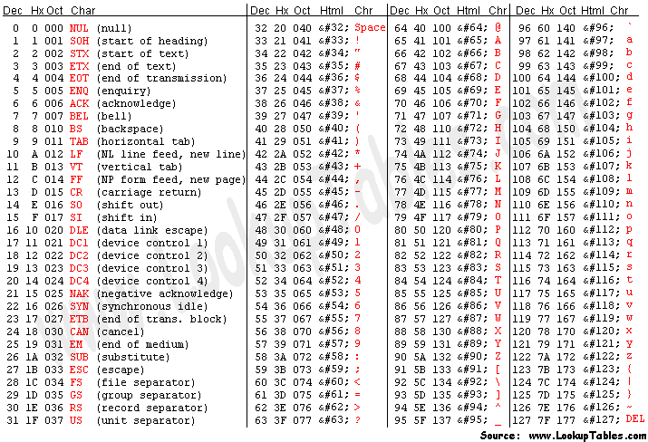

Functions Used:

We have used three fundamental functions defined within the system. These functions are fundamentally system calls used in the Linux operating system. The functions with their system call number has been defined by Linus Torvalds.
The 32-bit system call table is found at:
https://github.com/torvalds/linux/blob/v4.3/arch/x86/entry/syscalls/syscall_32.tbl
The 64-bit system call table is found at:
https://github.com/torvalds/linux/blob/v4.3/arch/x86/entry/syscalls/syscall_64.tbl

On program startup, the integer file descriptors associated with the streams stdin, stdout, and stderr are 0, 1, and 2, respectively. The preprocessor symbols STDIN_FILENO, STDOUT_FILENO, and STDERR_FILENO are defined with these values in <unistd.h>.

During execution of any assembly program, this file <unistd.h> is automatically loaded into memory and is visible at all times for the program. This file in turn brings into scope the system call table and integer file descriptors for the running program.

The functions we have used in this program are:

- int sys_write(int fd, unsigned char *mem, unsigned int len)
This function is abbreviated as syscall number 4(0x04) in x86 programs and syscall number 1(0x01) in x86_64 programs. It takes three arguments. We pass those arguments in registers as prescribed by the syntax given below:
x86 x86_64
ebx = file descriptor (fd) rdi = file descriptor (fd)
ecx = pointer to mem (*mem) rsi = pointer to mem (*mem)
edx = length of mem in bytes (len) rdx = length of mem in bytes (len)
The number of bytes successfully written is returned in eax/rax.

- int sys_read (int fd, unsigned char *mem, unsigned int len)
This function is abbreviated as syscall number 3(0x03) in x86 programs and syscall number 0(0x00) in x86_64 programs. It takes three arguments. We pass those arguments in registers as prescribed by the syntax given below:
x86 x86_64
ebx = file descriptor (fd) rdi = file descriptor (fd)
ecx = pointer to mem (*mem) rsi = pointer to mem (*mem)
edx = length of mem in bytes (len) rdx = length of mem in bytes (len)
The number of bytes successfully read is returned in eax/rax.

- int sys_exit(int ret_val)
This function is abbreviated as syscall number 1(0x01) in x86 programs and syscall number 60 (0x3c) in x86_64 programs. It takes three arguments. We pass those arguments in registers as prescribed by the syntax given below:
x86 x86_64
edi = return value rdi = return value

Mathematical model:

